接口一开始有兩种游玩模式可以选择:

玩家在选择之前可以先输入自己的User名称方便之后Rank排名显示

1. **General模式 – 新增多种辅助功能**

游玩守则:

每消耗20条line即level+1，掉落速度也增快

若User在抵达threshold line之前就按下space trigger Hard Drop的话就可以得到较高分数(需要一条threshold line)

志在驱使玩家动用最少步数与转数，每次的移动都会扣Score，仅按”下”不会。(故一开始需要一些基本分方便第一步运行)

最终排名显示level，旨在让玩家最大化利用Score来达到最高的level，以level为判断优劣基准，Score为辅助。当Score为负时即Game over。

*Score Exchange: (玩家目前積分可以兌換時，屏幕上會亮燈顯示可兌換項目)*

a. 兑换想要的block

- 空白处列出所有block图案，按下相對數字後則直接變換block(1-7 -> seven block to choose)

- 按下shift鍵，即可丟棄目前block，切換下一個block。

b. 兑换Bomb

- Bomb可以直接消掉Bomb降落在的那一整条line

c. 兑换speed趋缓

- 降落速度回到上一级(降落速度達到一定值後則不再增加)

1. **计时模式 – 在时间内完成目标**

游玩守则:

玩家在一开始可以選擇自己要挑战的难度與是否雙人遊完，分成简单、中等、困难。根据不同的难度分别对应不同的要求消耗数。需要一个Timer在接口上倒数，剩余的时间会换算成积分，最终进行排名。

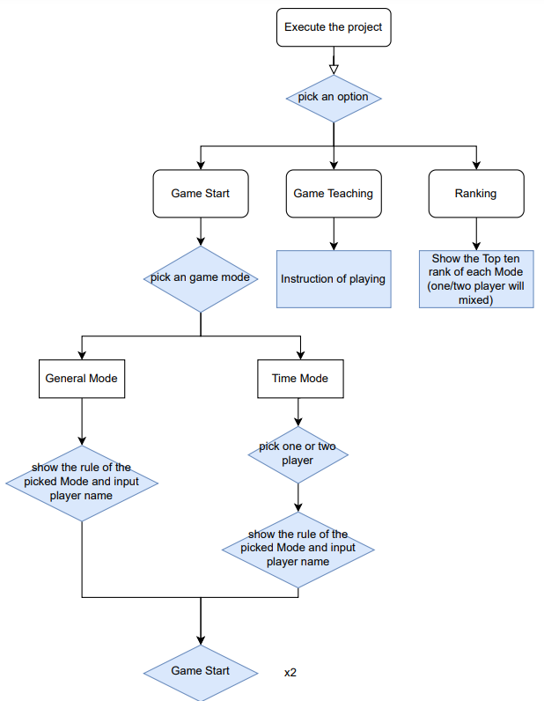

**Interface: (Blue BG color)**

1. Game Start:
2. General Mode
3. Time Mode – one player, two player mode
4. Game Teaching: Instruction - How to control?
5. Ranking: Show the top ten record score in each game mode with the player name and score.

**Rule in General Mode:**

Bonus: Hard drop, combo(twice or above in one time) and chain elimination(sequentially eliminate in different time).

Score:

Score will start from 100.

Every step(up,left,right) cost 1 point.

Exchange specific block, it cost 500 point.

Pass the current block(shift), cost 100 point.

Exchange Bomb, cost 750 point.

Exchange Low Speed, cost 1000 point.

combo: If the eliminate line is x, the score will plus like...以此類推

|  |  |  |  |  |  |  |  |  |
| --- | --- | --- | --- | --- | --- | --- | --- | --- |
| x | 1 | 2 | 3 | 4 | 5 | 6 | 7 | 8 |
| point | 20 | 45 | 75 | 110 | 150 | 195 | 145 | 200 |

chain elimination: 連續消除

連續一次point * 0.25，兩次0.5，三次0.75，四次1.0，五次1.25…以此類推

(假設已經連續第三次消除，而第三次消除了4條line，則110*(1+0.75))=192.5->193 point (四捨五入)

Hard drop, plus 5 point.

**Rule in Time Mode: 先以one player能做出來為主**

Easy Goal: eliminate 20 lines in 3 minutes

Medium Goal: eliminate 25 lines in 3 minutes.

Hard Goal: eliminate 30 lines in 3 minutes.

Approach the goal:

Easy, plus 1000 points. Medium, plus 1500 points. Hard, plus 2000 points.

The remaining time: 1s -> 20 points.

分工:

General Mode: 2p

Time Mode: 1p

Interface and game design : 1p